**PHYSICAL SCIENCES – GRADE 12**

**VERTICAL PROJECTILE MOTION IN 1D**

|  |  |  |
| --- | --- | --- |
| **Lesson** | **Date** | **Topic** |
| 2 | 15 February 2025 | Vertical projectile motion: Part 1 |
| 3 | 22 February 2025 | Vertical projectile motion: Part 2 |

**Definitions (as per DBE examination guidelines 2021)**

|  |  |
| --- | --- |
| **Term/ Concept** | **Definition/ Description** |
| **Projectile** | An object which has been given an initial velocity and then it moves under the influence of gravitational force only. |
| **Free fall** | Motion during which the only force acting on an object is the gravitational force. |

**Question 5**

A hot-air balloon moves vertically downwards at a constant velocity of 1,2 m.s-1. When it reaches a height of 22 m from the ground, a ball is dropped from the balloon.

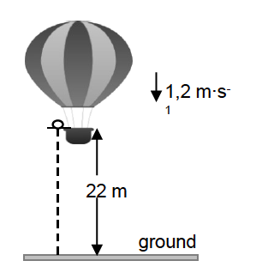

1,2 m.s-1

Assume that the dropping of the ball has no effect on the speed of the hot-air balloon. Ignore air friction for the motion of the ball.

5.1 Is the hot-air balloon in free fall? Give a reason for your answer.

5.2 Calculate the time it takes for the ball to hit the ground after it is dropped.

When the ball lands on the ground, it is in contact with the ground for 0,3 s and then it bounces vertically upwards with a speed of 15 m.s-1.

5.3 Calculate how high the balloon is from the ground when the ball reaches its maximum height after the first bounce.

**DBE MAY/ JUNE 2021**

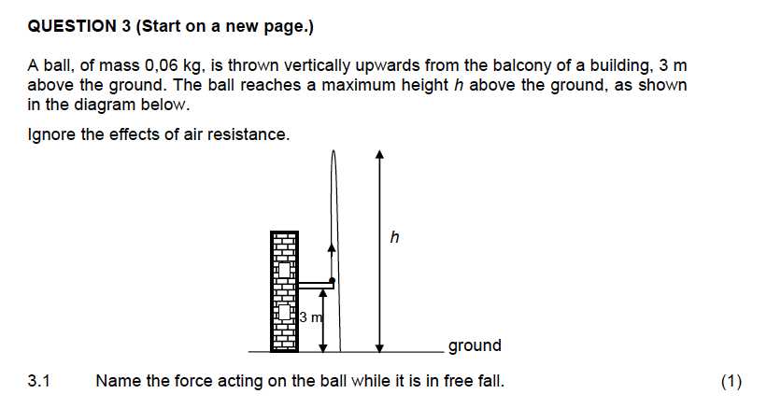

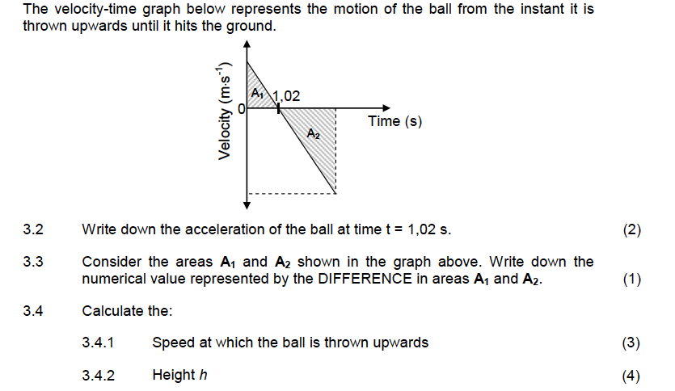

**DBE MAY/ JUNE 2022**

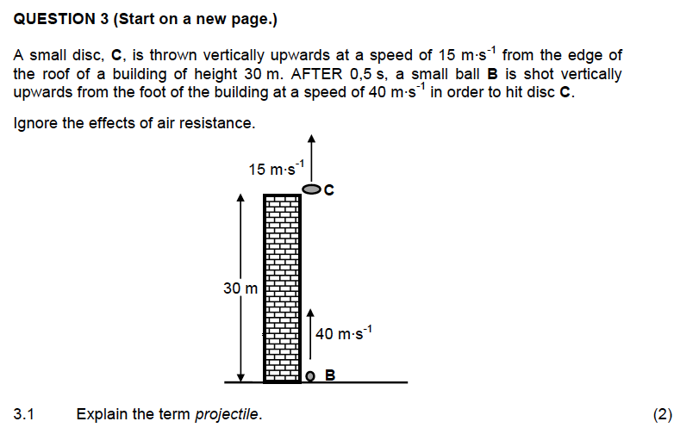

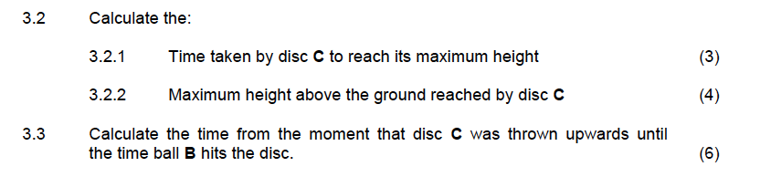

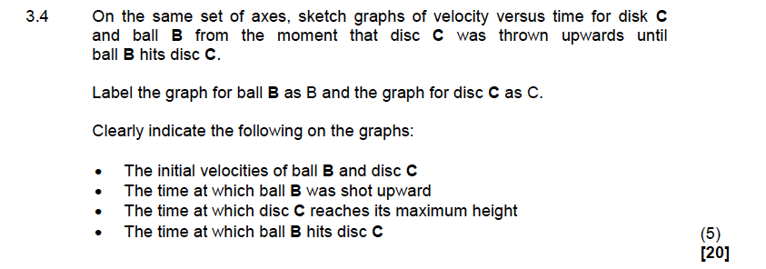

**FS July 2021**



